**Written for The Worker, 2nd Quarter 2020 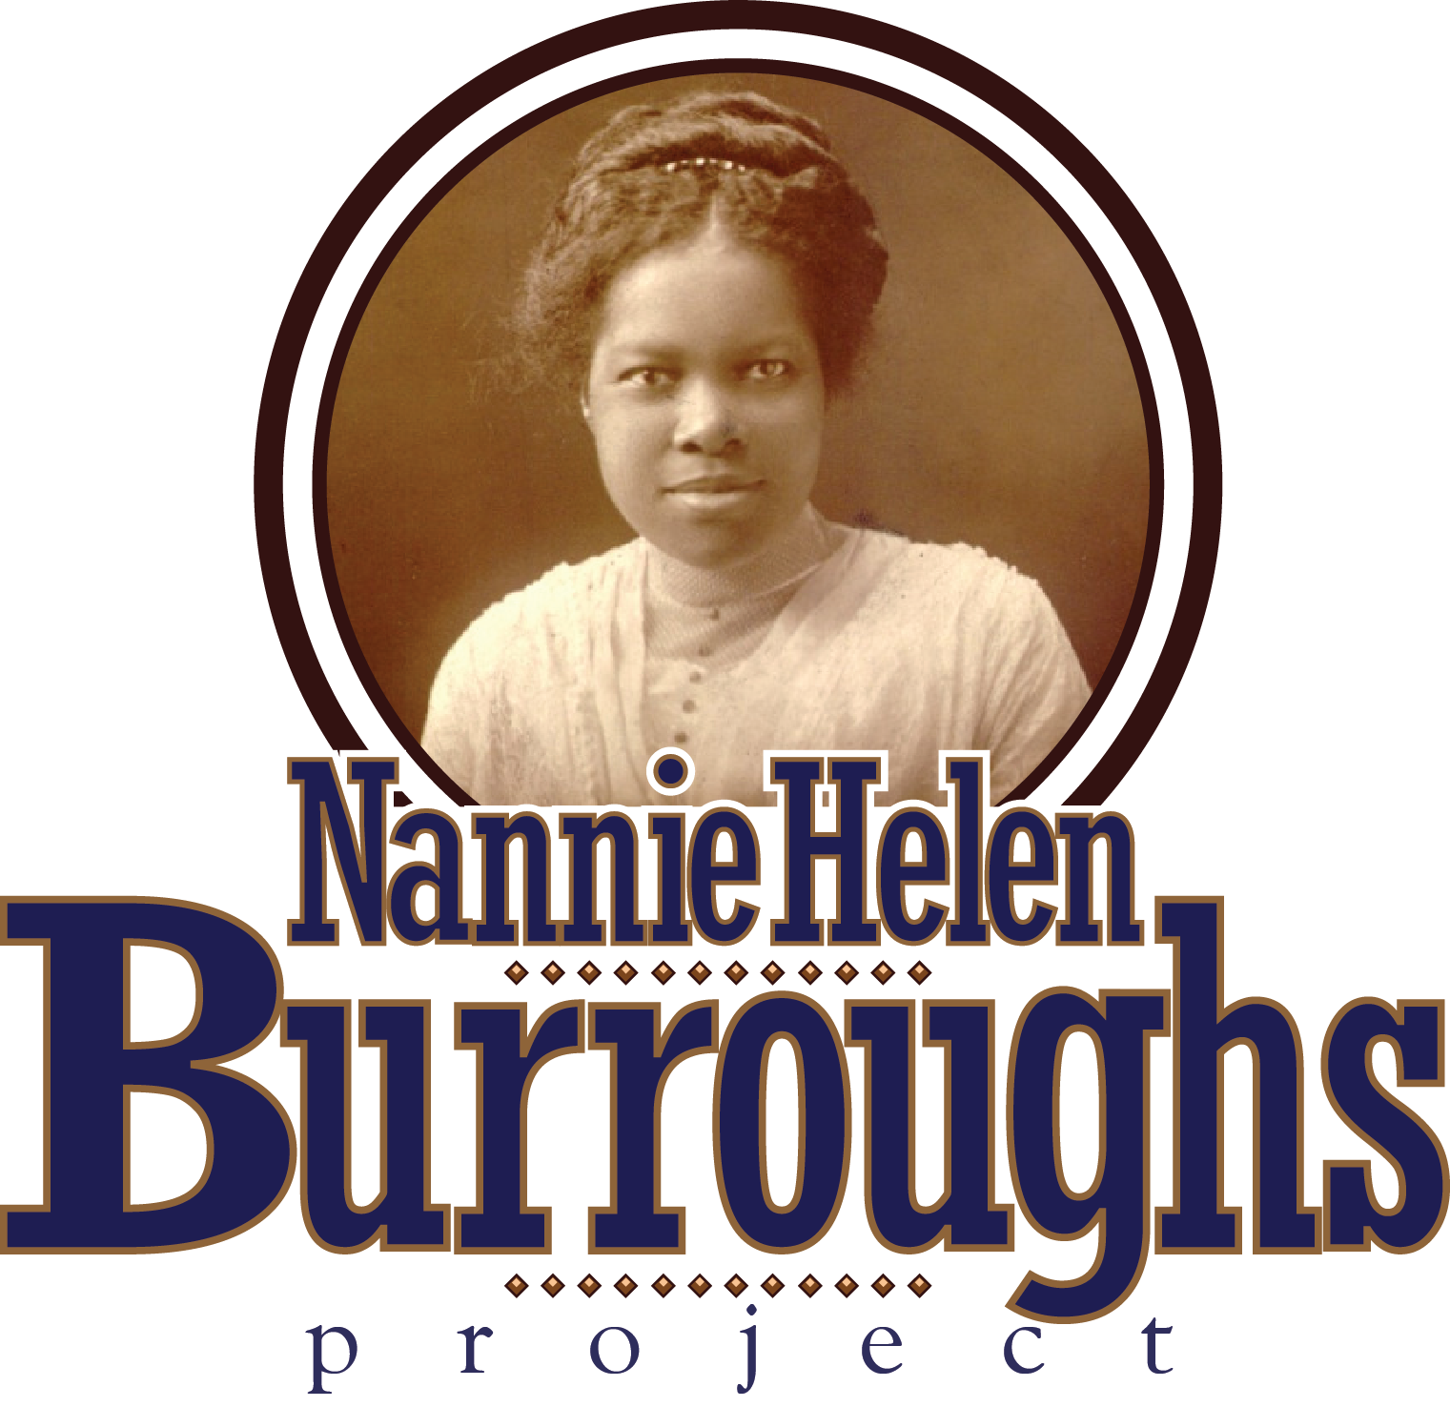by Colonel James Wyatt**

**What Would Jesus Do? (WWJD) is a popular bumper sticker. It grew out of the Biblical concept of the “Imitatio Christi” or the “Imitation of Christ”, a teaching stressed in The Roman Catholic Church. Reverend Charles Sheldon introduced the concept to a wider audience in 1890, when he was pastor of the Central Congregational Church of Topeka, Kansas. One Sunday he preached a sermon entitled, What Would Jesus DO? It became a series of sermons, which resulted in a significant increase in the congregation. He eventually wrote a book on the concept, entitled In His Steps.**

**Nannie Helen Burroughs built upon this concept at the 1920 NBC, speaking to how we could better learn to “Imitate God…following the example of Christ…” (Ephesians 5:1-2) by bringing the message to the masses: “We might as well be frank and face the truth…the majority of our religious leaders have preached too much heaven and too little Christian living…”. Five years ago, I had the privilege of speaking at the Paul Lawrence Dunbar Senior Citizens Apartments here in Washington, DC. A gentleman approached me and said: “I was Miss Burroughs’ driver during the last year of her life. I would pick her up every morning, and all she talked about was the children.” Our Editorial Perspective deals with raising our children. And Nannie Helen Burroughs understood that our children mimiced and imitated what they saw in their parents and other adults. So, at the National Training School for Negro Women and Girls and her Summer Retreat Institute on Minnesoto Avenue, she relied upon her relationship with God to “Imitate God”, recognizing “We Needed to be like God” in teaching the children.**

* **As the driving force behind establishment of the Frederick Douglass Museum, Burroughs was wedded to his quote: “It is easier to build strong children than to repair broken men”.**
* **From a Carnegia Gordon interview (Student 1928-29): Burroughs mingled, knew them by name; asked about parents and grades; joined them for breakfast, attended assemblies; learned how to work and share with others; and learned black history and pride and how to walk with head up.**
* **Nannie lived up to the advice of her father: “…never steal, always tell the truth, and do what you are told to do the best you can and in a hurry”.**
* **Nannie and Character: 1. “There is as much character in Ebony as there is in Marble…” NHB, 1925. 2. I Am Somebody…I am a moulder of character in Nannie Burroughs, Dr. William Borders, Morehouse College, 1943 - Google UTube. 3. “…Character…not color…” NHB, 1950.**

**Nannie Helen Burroughs’ legacy might well be that she lived her life according to a set of standards. However, she alluded to one standard near the time of her demise in 1961 which seems to suggest the difference between then and now: “Everything in the modern household is controlled by swiches, xcept the children”. In jest, I believe my mother hung out with with her. Dr. E. L. Harrison, Pastor of Shiloh Baptist Church and a friend described her in his book, The Dream and the Dreamer as follows: “…She was courageous, charming and dynamic to the point that she was irresistible to the open-minded and contemptible to the jealous and prejudiced”. WWJD? Nannie Helen Burroughs did what Jesus would do!**