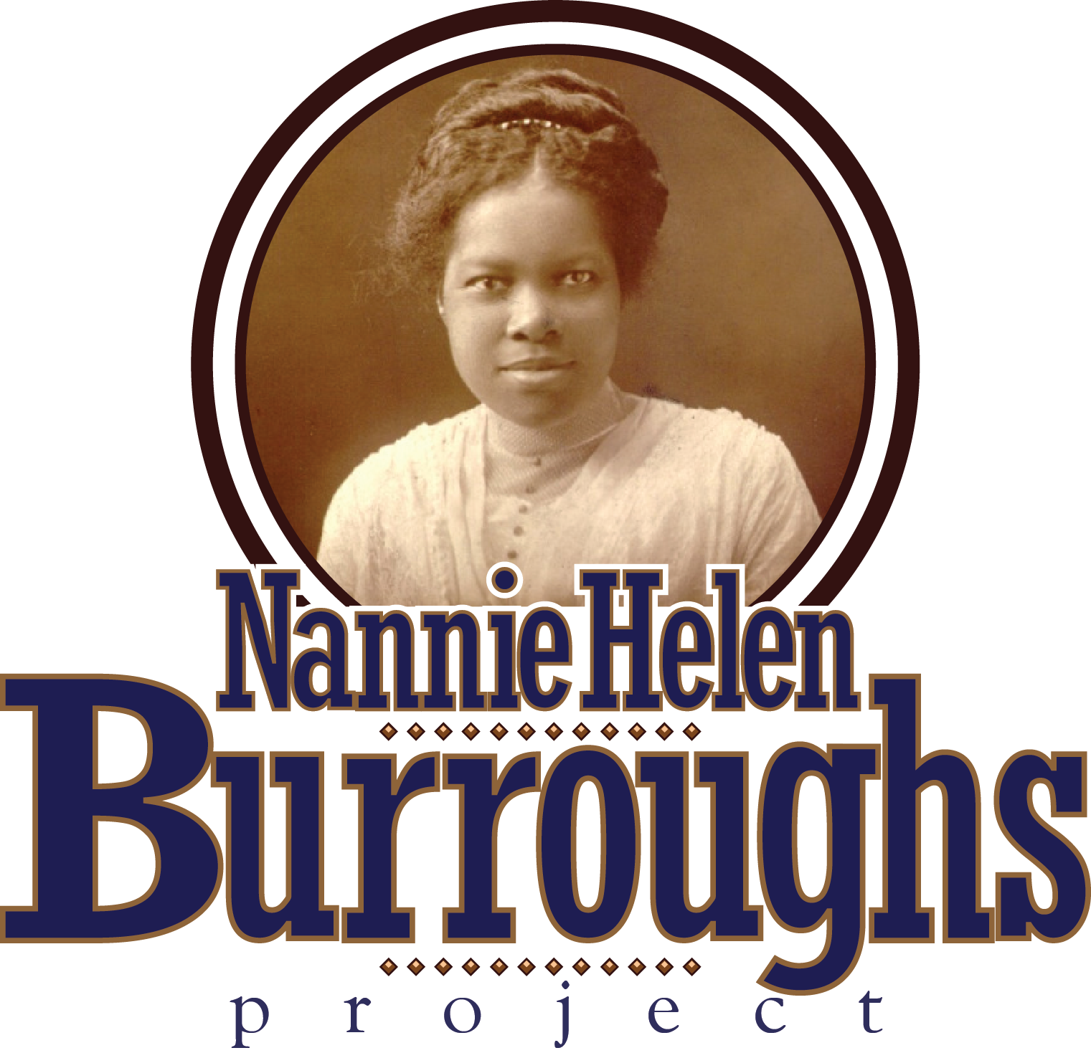

[www.nburroughs](http://www.nburroughs) info.org

**James E Wyatt (Colonel, U.S. Army, Retired), Founder**

**BURROUGHS IN AN ARTICLE, CIRCA 1942, ABOUT MOTHERS, CHILDREN, HOME AND SCHOOL**

**------------------------------------------------------------------------------------------------------------------------------------------------------**

**IF EVER THAT APHORISM IS TRUE, IT IS TODAY. MOTHERS ARE WAR WORKERS. LITTLE CHILDREN AND TEEN-AGE GIRLS ARE LEFT AT HOME TO SHIFT FOR THEMSELVES. WHAT THE HARVEST (MORAL AND SOCIAL) WILL BE, ONLY GOD KNOWS.**

**TOO MANY PARENTS ARE GOING TO LOSE MORE THAN THEY GAIN. WHAT WILL IT PROFIT THEM TO MAKE MONEY AND FACE THE FACT THAT WHILE THEY WERE HERE AND THERE, THEIR CHILDREN WENT TO THE DOGS, OR THE DOGS CAME INTO THEIR HOME AND GOT THEIR DAUGHTERS? MOTHERS OF TEEN-AGE GIRLS, TAKE OUR ADVICE. “YOU BETTER MIND” BEFORE IT IS TOO LATE. OUR RACE WILL BE MORALLY BANKRUPT IF PARENTS DO NOT PUT FIRST THINGS FIRST IN THE CARE AND PROTECTION OF THEIR DAUGHTERS. IF THEY MUST BE AWAY ALL DAY, THEY SHOULD SEND THEIR DAUGHTERS TO THE BEST CHRISTIAN BOARDING SCHOOL, SO THEY CAN GET THE KIND OF TRAINING THAT WILL PREPARE THEM FOR THE GREAT DAY OF ECONOMIC COMPETITION THAT IS SURELY COMING.**

**GIRLS MUST BE GIVEN DEFINITE BASIC TRAING IN CHARACTER IDEALS. IF THERE IS NOBODY AT HOME, THEY SHOULD BE SENT TO SCHOOLS THAT WILL LAY THE FOUNDTION. PRIMPING, PAINTING, POLISHING, PARADING, AND PHILANDERING ARE THE BIGGEST THINGS THAT OUR LITTLE GIRLS ARE DOING NOW. THERE ARE GIRLS WHO ARE TOO FINE AND TALENTED TO BE ALLOWED TO GO TO WASTE. OUR SCHOOLS CAN AND MUST GIVE THEM THE KIND OF TRAINING THEY SHOULD GET AT HOME. OUR EDUCATORS, WHO HAVE THEIR EYES OPEN AND THEIR VISION CLEAR, KNOW CONDITIONS. THE TRUE HEARTHED ONES ARE GRIEVED AND AND BAFFLED OVER THEM. WE MUST IMPROVE THE MORAL QUALITY OF OUR TEACHING AND SHOW BY OUR OWN LIVES WHAT CHARACTER IN EDUCATION REALLY IS. WE MUST MAKE NOBLE LIVING CONTAGIOUS.**

**EDUCATION TO BE OF VALUE MUST PREPARE STUDENTS TO DO THEIR WORK SKILLFULLY, AND TACKLE IT ENTHUSIASTICALLY. THE GREATEST SERVICE THAT A SCHOOL CAN RENDER IS TO HELP YOUNG PEOPLE DISCOVER THEIR TALENT AND AND GLORIFY IT THROUGH TRAINING AND DEVOTED SERVICE. THIS IS THE REAL END OF EDUCATION. THIS IS THE ONLY REWARD THAT PARENTS AND FRIENDS WHO INVESST IN EDUCATION EXPECT, OR DESIRE. THIS IS THE ONLY WAY TO MAKE EDUCATION PAY.**

**OUR SCHOOLS MUST PRODUCE A FINE BRAND OF GRADUATES. BY THAT I MEAN WE MUST WORK HARDED THAN EVER TO DEVELOP IN THEM COMMON SENSE, GENUINE CULTURE, AND A PASSION FOR WORK. YOU MIGHT ASK WHAT AM I TRYING TO DO TO MEET SOME OF THESE NEEDS? IN OUR SCHOOL WE OFFER A PROGRAM THAT ARE SHOT THROUGH WITH THE TEACHING OF GOOD MANNER, (AFTER ALL, GOOD MANNERS HAVE NOT GONE OUT OF STYLE, YOU KNOW) MORALS AND THE TEACHINGS OF JESUS CHRIST ABOUT LIFE AND ITS HIGH PURPOSE.**

**WE BRING OUR STUDENTS INTO VITAL CONTACT, DAILY, AND WITH THE GREATEST MOTIVATING FORCE OF LIFE – RELIGION. WE TEACH THEM HOW TO LIVE IT. WE EMPLOY WELL-TRAINED CHRISTIAN TEACHERS, WHO ARE EXAMPLES FOR YOUNG PEOPLE. ALL OF THE FUNDAMENTAL VALUES OF LIFE ARE INTEGRATED WITH ACADEMIC SUBJECTS. WE MAKE THESE BASIC PRINCIPLES THE LEAVEN IN A LUMP. WHEN ACADEMIC SUBJECTS ARE ARE ENRICHED BY PROPER TEACHING OF CHRISTIAN IDEALS, MIXED WELL AND TAKEN REGULARLY, THEY TRANSFORM LIVES AND GIVE LIFE STRENGHT AND MEANING.**

**OUR GREATEST DESIRE IS TO SEND YOUNG WOMEN OUT FROM THIS SCHOOL TO CONTRIBUTE THEIR PART IN HELPING TO IMPROVE HOME LIFE AND REMAKE THEIR COMMUNITIES. WE INSIST THAT EVERY GIRL SHOULD KNOW HOW TO DO AT LEAST ONE THING SUPERBLY WELL. TO THAT END, WE OFFER STANDARD ACADEMIC COURSES – JUNIOR HIGH, HIGH SCHOOL AND JUNIOR COLLEGE AND TRADE COURSES. OUR THREE-FOLD PURPOSE IS: 1. DEVELOP EVERY STUDENT IN POSITIVE CHARACT TRAITS – THE RIGHT ATTITUDE TOWARDS WORK AND PRIDE AND SKILL IN THEIR CHOSEN PROFESSION. 2. PREPARE THEM TO ENTER COMPETITION WITH ANY AND ALL WORKERS WHO ARE ENGAGED IN THE SAME FIELD, WITHOUT FEAR OR APOLOGY. 3. PREPARE THEM TO CLEAN UP THE ENVIRONMENT IN WHICH THEY LIVE.**

**WE CALL OUR SCHOOL : “THE SCHOOL OF THE 3 B’S, BIBLE, BATH AND BROOM” – SYMBOLIC OF CLEAN LIVES, CLEAN BODIES, AND CLEAN HOMES. THIS IS MORE THAN A FELICITOUS SOBRIQUET, BECAUSE THE RACE THAT EXCELS IN IN THE USE OF THESE THREE REQUIREMENTS IS THE MOST CIVILIZED. THE AMERICA OF TOMORROW WILL STRESS SKILL AND PRIDE IN THOSE SERVICES THAT CONTRIBUTE MOST TO THE HEALTH, STRENGHT AND CHARACTER OF EACH INDIVIDUAL IN THE NATION, WHEREVER HE OR SHE LIVES, AND IN THE DEFINITE IMPROVEMENT OF HOME LIFE.”**