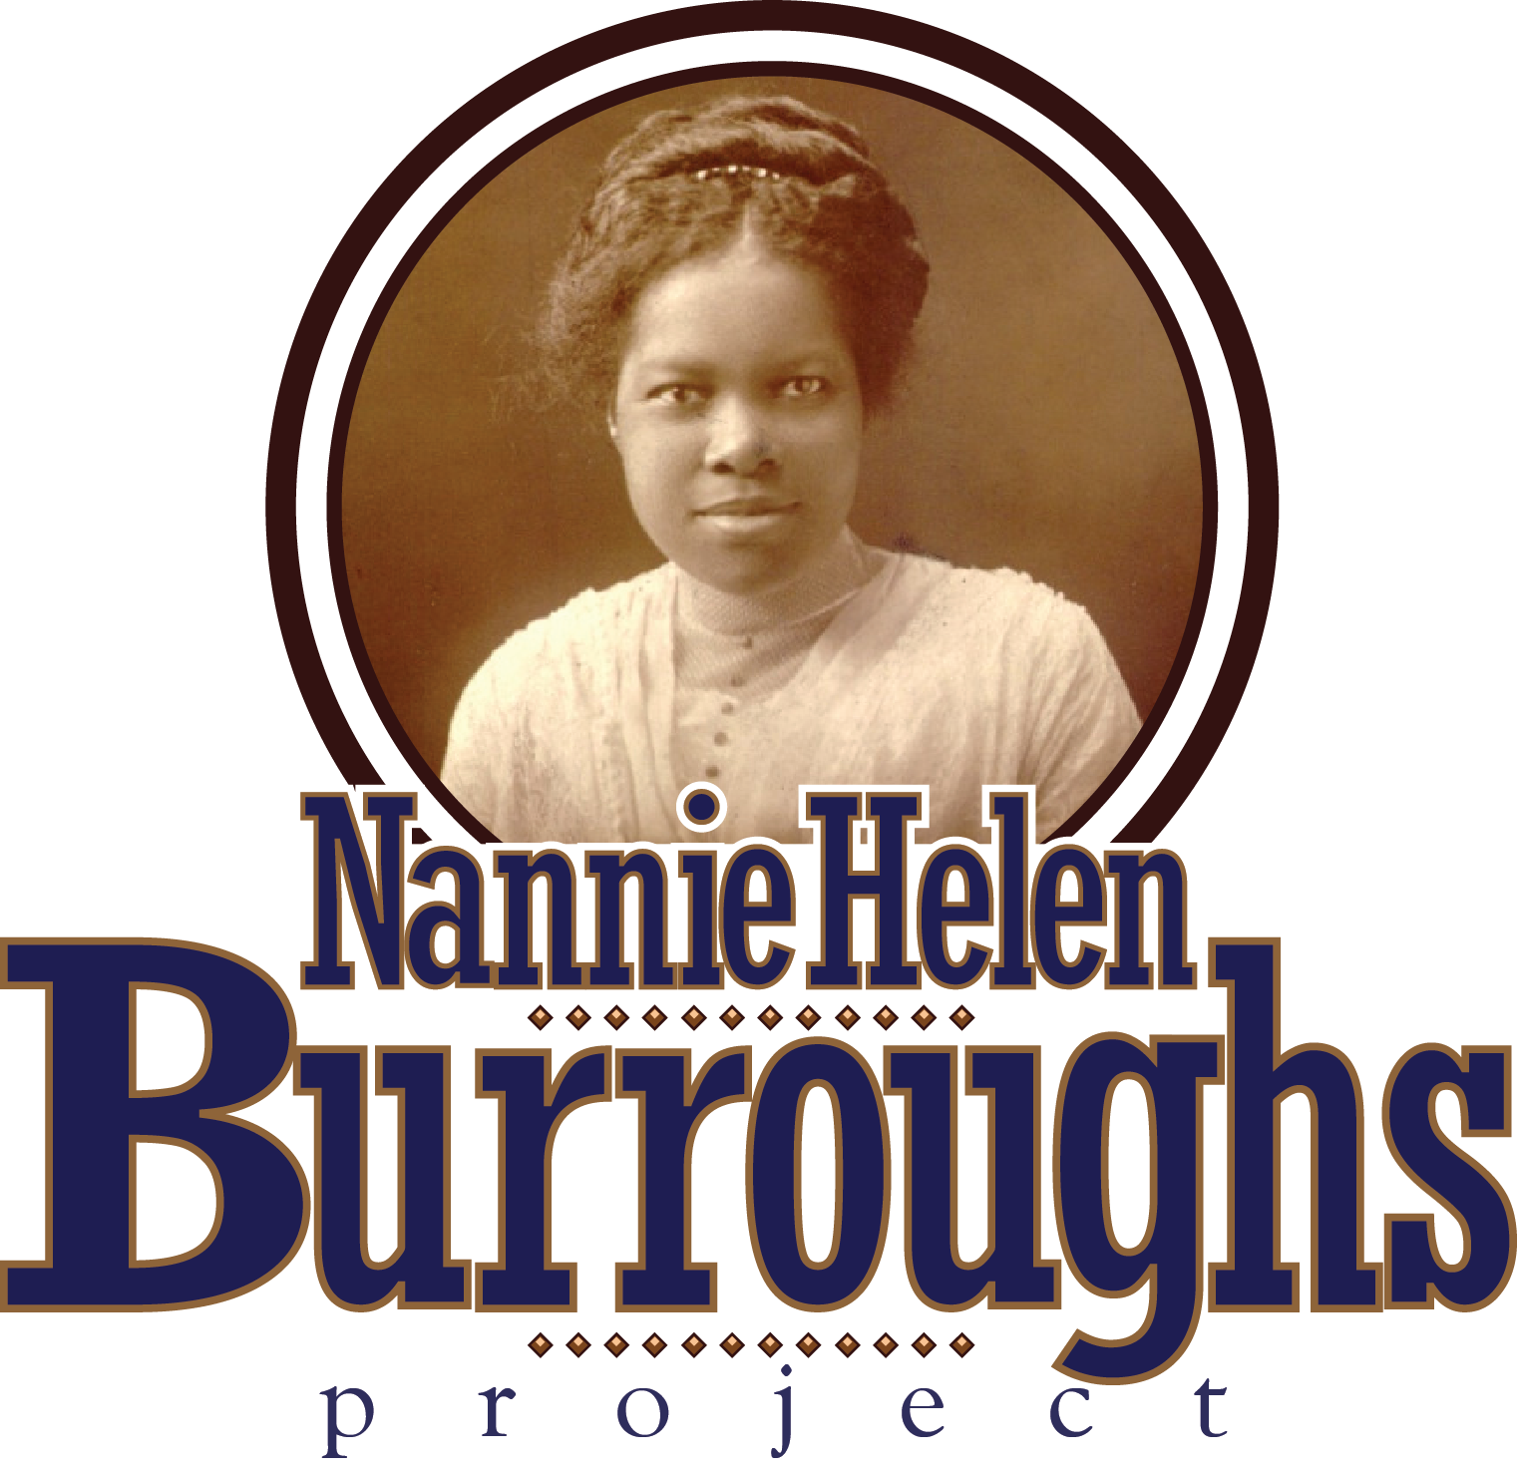

**Remembering a D.C. Trailblazer**

**The February 26, 2015 edition of the Washngton Informer carried an article entitled, *D.C. Trailblazer: Nannie Helen Burroughs*. I was reminded of that article when I particpated in the National Parks Service’s February 15, 2020 celebration of Frederick Douglass’ Birthday. The following excerpt of an article by Nannie Helen Burroughs appeared in the Baltimore Afro-American, July 20, 1935; p. 16: “…If people loved and desired to cherish the name Frederick Douglass, they would make that fourteen acre plot known as “Cedar Hill” look like Mount Vernon…”. Cedar Hill did come to look like Mount Vernon, and because of her involvement represents but one of the many contributions that the “Traiblazer” made to Washington D.C.**

**The month of May is central in the life and works of Nannie Helen Burroughs and presents an opportunity for us to remember all she did for our city, women, race and country. She was born on May 2, 1879 in Orange, Virginia and brought to Washington by her mother when she was five years-old. In 1975, Mayor Walter Washington Proclamed May 10 “Nannie Helen Burroughs Day” in D.C. In 2014 and 2015, Congresswoman Eleanor Norton Holmes and Mayor Muriel Bowser, respectively, confirmed this proclamation. She passed on May 20, 1961. And, her Home Going Service was held on May 25, 1961 at the Nineteenth Street Baptist Church in Washington, D.C.**

**Of her many contributions, I think we all can agree that the most significant was the establishment of the National Trade and Professional School for Women and Girls in 1909, which closed in 2013 as co-educational kindersgarden to sixth grade. As an 1896 graduate of M Street School, now Dunbar, the first black public high school in the country, Nannie was clearly influenced by two of Washington’s truely great black women, Anna Julia Cooper and Mary Church Terrel. Both were teachers at M Street School, with Cooper later becoming principal. Terrell later became the first black woman in America to be appointed to the school board of a major U.S. city. It is amazing that Burroughs, as a recent high school grauduate, joined Terrell and Cooper among the women to form the National Association of Colored Women in 1896. Of interest in starting the school is her consideration of the views of our black leaders. Booker T. Washington wanted her to open the school in the south, as in the cases of Lucy Laney, Charlotte Hawkins Brown and Mary McLeod Bethune. She insisted, however, that the school would be placed in Washington, D.C., the seat of the U.S. Government. Further, while she embraced the trade educational views of Washington, she established a Bi-lateral curriculum which incorporated the views of Washington and W.E.B. Du Bois. Anna Julia Cooper favored the classical studies of Du Bois. More important is for us to remember Burroughs’ objectives for the school, and how we might consider them for our children today. Here is an except from a 1942 speech: “…We insist that every girl should know how to do at least one thing well. To that end, we offer standard academic courses – junior high, high school and junior college and trade school. Our three-fold purpose is: 1. Deveop every student in positive character traits – the right attitiude towards work and pride and skill in their chosen profession. 2. Prepare them to enter into competition with any and all workers who are engaged in the same fields, without fear or apology. 3. Prepare them to clean up the environment in which they live…”**

**Her contributions for the city were far beyond education. She established the Women’s Auxiliary to the National Baptist Convention and “Woman’s Day” in the Baptist Church in 1902 and 1907, respectively, as a member of the Nineteenth Street Baptist Church. And, in 1905, brought praise to the city from around the world, when she was the keynote speaker before 18,000 people in Hyde Park, London at the first Baptiat World Alliance Congress, whose headquarters is located in Alexandria, Virginia. The London Daily Express Newspaper quoted one of her “oratorical gems”. “It is useless to telgraph to heaven a shipload of blessing and not be on the wharf to unload the vessels when they arrive.” Finally, Burroughs added to the business life of our commumity, when she was elected President of the Northeast Self-Help Cooperative in 1934.**

**The aforementioned Washington Informer article about Nannie Helen Burroughs was wriiten after an interview with Mr. Eric Gray, Basileus of the UDC Omega Psi Phi Fraternity Chapter. Mr. Gray had sponsored a presentation on campus about the life and works of Nannie Helen Burroughs. During the interview with the writer, Ms. Sarafina Wright, he commented: “…I thought this program was necessary. Not a lot of people know about her…There was a need to learn this.” I gave the presentation, having joined Mary Alice Dorsett (1926 – 2017), a favorite student of Miss Burroughs in 1947-51, who had been advocating for the views and vision of Nannie Helen Burroughs since graduation. Mary Alice, of Tampa, Florida, had been recognized by The Greater Washington Urban League for her work at their 22nd Annual Whitney M. Young Jr. Memorial Dinner in 1994. Even Miss Burroughs acknowledged that her message was not being heard by “the people” (see Mary Alice Dorsett and the message on my website,** [**www.nburroughsinfo.org)**](http://www.nburroughsinfo.org))**. So, I have selected another approach, going forward, to pass her message to what Miss Burroughs occasionally called “The masses”. I am p[anning to establish a Nannie Helen Burroughs School Alumni Club. The mission of the club will be to bring her message across the country to the young people in our elementary and high schools and HBCUs. Of course, this will entail a rigorous course of study about her life and works. My hope is that young people who went to the school will be more effective in interacting with other young people. As Mr. Gray said: “…There was a need to learn this.”**

**Hopefully, the above will help us to remember this “D.C. Trailblazer”. Going forward, I ask all who can help locate alumni and/or are otherwise interested in this endeavor, including possible legal implications, to please contact me at the address shown on the website.**

**Her Home Going Service on May 25, 1961 at the Nineteenth Street Baptist Church in Washington, D.C. was a three-hour service, attended by eight hundred people, including ninety-five ministers, of whom nine spoke from the pulpit. First Lady Eleanor Roosevelt sent flowers. The Eulogy was delivered by Dr. Earl L. Harrison, Pastor of Shiloh Baptist Church of Washington, D.C.: “…We pay tribute to a great woman today. She was fearless and self-possessed, poised and intelligent…She left an unwritten blueprint for devout builders. God grant that she will not have lived in vain.” He Signed it: “Her Friend”**

**James E. Wyatt (Colonel, US Army, Retired)**

**Founder, The Nannie Helen Burroughs Project**

**www.nburroughsinfo.org**