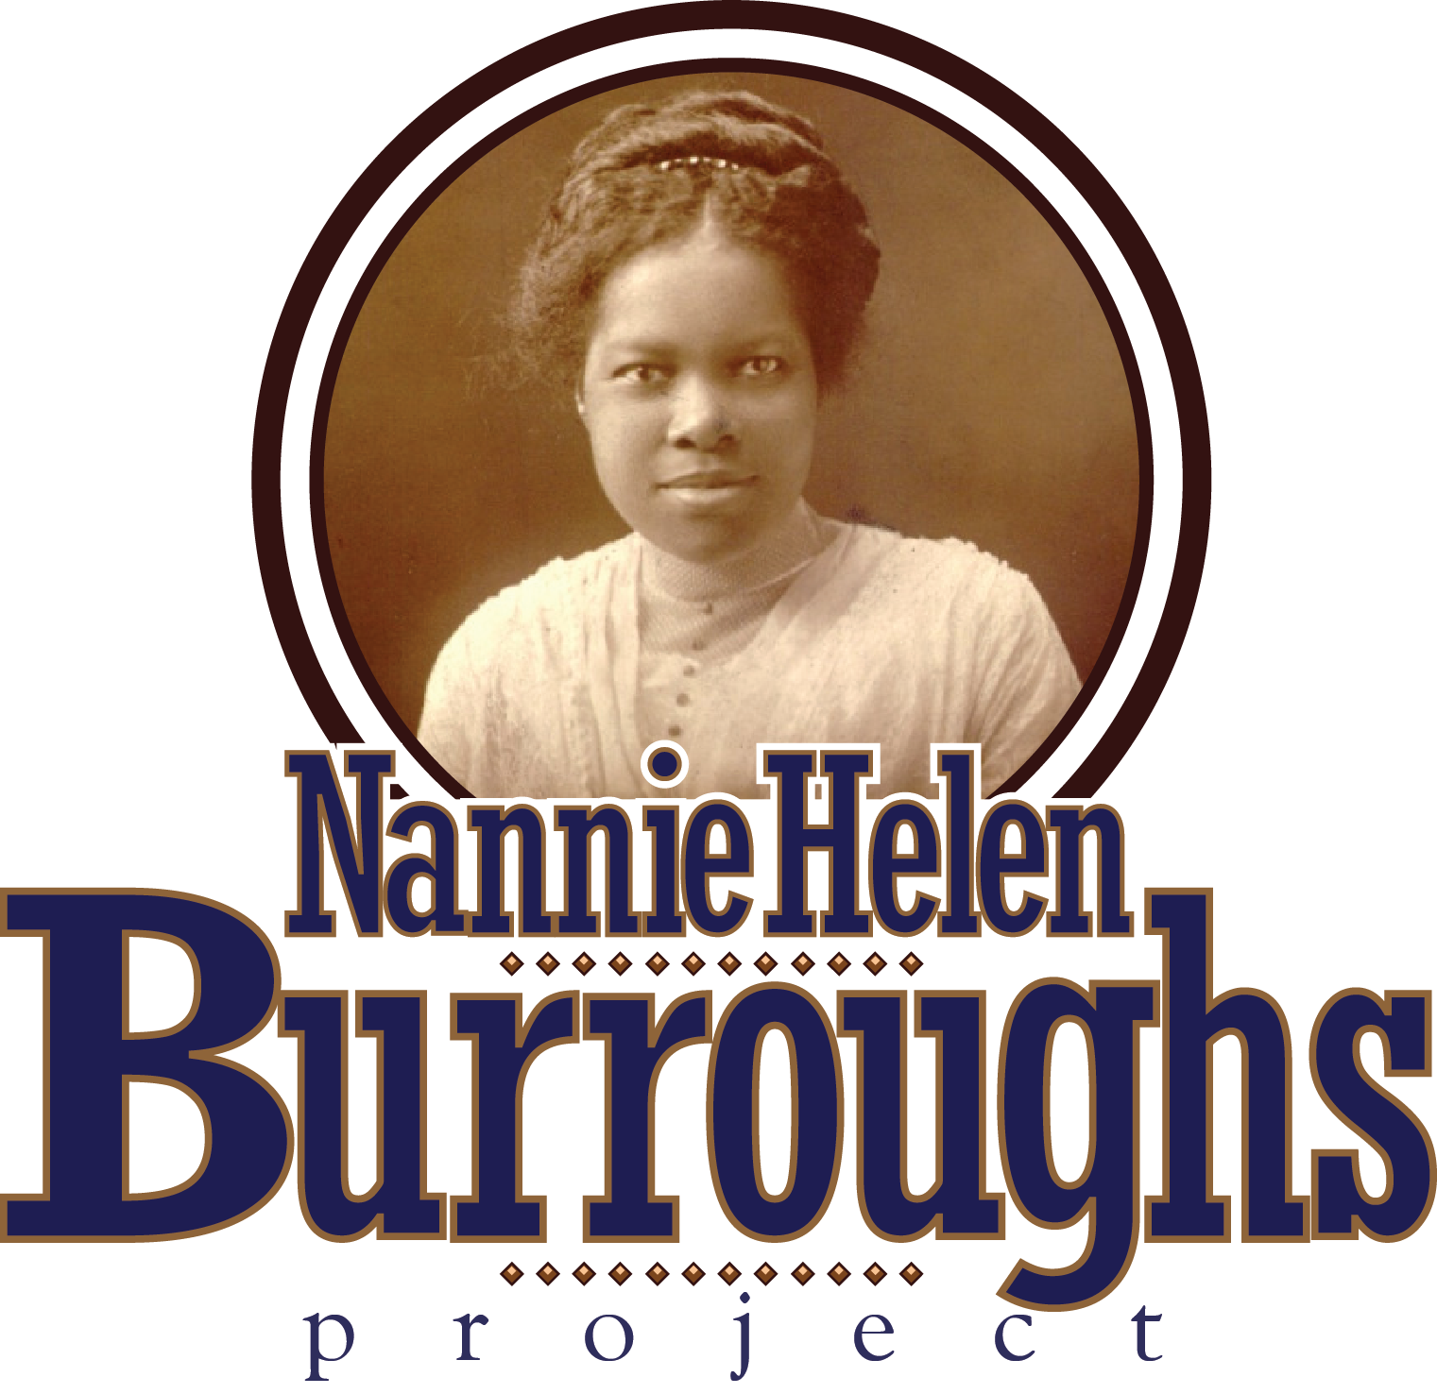

[**www.nburroughsinfo.org**](http://www.nburroughsinfo.org)

**Colonel (ret.) James E. Wyatt, Project Founder**

**REFLETIONS OF DR. GENNA RAE MCNEIL FROM THE JOURNAL OF THE ASSOCIATION FOR THE STUDY AFRICAN AMERICAN LIFE AND HISTORY, DATED SUMMER 2011**

**“INTREPID AND CHARISMATIC, CONFIDENT THAT HER WORK WAS RIGHTEOUS AND IMPORTANT FOR THE**

**RACE, NANNIE HELEN BURROUGHS WAS AN IMPRESSIVE CHRISTIAN WOMAN, BAPTIST LEADER, AND**

**EDUCATOR. AT HER TRAINING SCHOOL THAT STOOD HIGH ON A HILL IN WASHINGTON, DC., SHE HAD SOME**

**ROOMS EQUIPPED ESPECIALLY FOR LITTLE GIRLS. AND AS I SAT IN ONE OF THOSE SMALL CHAIRS (SO THAT MY**

**FEET COULD TOUCH THE FLOOR), I WAS MESMERIZED AND EXCITED. MY FATHER, REVEREND DR. JESSE JAI**

**MCNEIL, MET WITH NANNIE BURROUGHS RELATIVELY OFTEN, FLYING IN FROM DETROIT TO DISCUSS THE**

**NATIONAL BAPTIST CONVENTION, USA, INC., THE TRAINING SCHOOL, AND THE SUNDAY SCHOOL PUBLISHING**

**BOARD IN NASHVILLE, TENNESSEE. ON THIS SPECIAL TRIP, THE CHILDREN WOULD FINALLY MEET THE FAMOUS**

**NANNIE HELEN BURROUGHS. FATHER HAD ALREADY PREPARED HIS CHILDREN AND SO I REMEMEBER THAT**

**MY OLDER BROTHER (WHO WAS PROBABLY ALMOST READY FOR THE FIRST GRADE) AND I LISTENED TO MISS**

**BURROUGHS WITH GREAT ANTICIPATION. WHEN SHE SPOKE, SHE ENGAGINGLY COMMANDED ATTENTION**

**WITH STRAIGHTFORWARD TALK AND PHRASES OR PRINCIPLES VITUALLY IMPOSSIBLE TO FORGET.**

**EXPEREIENCES WITH HER AS A CHILD LEFT ME REMEMBERING SEVERAL THINGS, IN NO PARTICULAR ORDER.**

**SHE ONCE HAD THE OPPORTUNITY TO BE FREDERICK DOUGLASS’S SECRETARY. SHE WAS THE FORCE BEHIND**

**THE FOUNDING OF “WOMAN’S DAY” IN THE NATIONAL BAPTIST CONVENTION AND AFFLIIATED CHURCHES,**

**AND SHE ALWAYS INSISTED THAT ALL CHURCH WOMEN---POOR OR WEALTHY, GRADE-SCHOOL EDUATED OR**

**COLLEGE GRADUATES---HAVE THE OPPPORTUNITY TO BE LEADERS ON “WOMAN’S DAY”. MY MOTHER, PEARL**

**WALKER MCNEIL, WHO WAS AN ACTIVE CHURCH WOMAN IN BAPTIST CIRCLES, THE LUCY THURMAN YMCA IN**

**DETROIT AND UNITED CHURCH WOMEN, TOLD ME THAT NANNIE BURROUGHD SELECTED WHITE DRESSES FOR**

**WOMAN’S DAY BECAUSE SOMEONE WHO EVEN WORKED IN DOMESTIC SERVICE HAD A WHITE DRESS.**

**NANNIE HELEN BURROUGHS TOLERATED NO EXCUSES AND DID NOT BELIEVE BLACK PEOPLE SHOULD MAKE**

**ANY. “GOD HELPS THOSE WHO HELP THEMSELVES”. AND ANYONE AROUND NANNIE HELEN BURROUGHS HAD**

**TO SHOW INITIATIVE AS WELL AS INTELLIGENCE, DISCIPLINE, HARD WORK, AND WILLINGNESS TO PRACTICE**

**UNTIL SHE OR HE GOT IT RIGHT. SHE WAS “OLD SCHOOL”; THERE WAS ONE STANDARD, NOTHING LESS THAN**

**THE BEST. SHE BELIEVED IN OUR RACE---NEGROES WITH A CAPITAL “N” --- OUR STRENGHT, OUR STAMINA,**

**OUR ABILITY TO HELP OURSELVES, OUR INTELLECT, OUR CAPACITY TO SPEAK FOR OURSELVES, OUR CAPACITY**

**TO FIGHT FOR OUR FREEDOM, AND OUR FAITH. SHE WAS INSPIRING, EVEN TO A CHILD.**

**WHEN I LEARNED THAT DR. BETTYE COLLIER-THOMAS HAD ENTITLED HER BOOK USING THE WORDS OF NANNIE**

**HELEN BURROUGHS, WHEN SHE DECLARED IN 1958 THAT THE NEGRO MUST HAVE “JESUS, JOBS AND**

**JUSTICE” I FELT I KNEW IN A PERSONAL WAY SOMETHING OF WHAT BOTH WERE SAYING…THAT THE AFRICAN**

**AMERIECAN WOMEN DID NOT LIVE AN EITHER/OR EXISTENCE---EITHER RELIGIOUS FAITH AND CHURCH**

**SERVICE OR SOCIAL ACTIVISM, POLITICS, AND MEMEBERSHIP IN SECULAR ORGANIZARIONS…AFRICAN**

**AMERICAN WOMEN HAVE LIVED AT THE INTERSECTION OF FAITH, FAMILY, FRIENDSHIPS, CHARITY, SERVICE,**

**PRAGMATISM, POLITICAL ACTION, ABOUNDING HOPE, AND THE FREEDOM STRUGGLE.**